Title: BERT-Based Automatic Question Classification Using Deep Learning

Abstract
Nowadays, students, teachers, and many online learning platforms deal with thousands of questions every day. Organizing these questions manually into different subjects or categories is time-consuming and can often lead to mistakes. This project aims to solve that problem by automatically identifying the category of a question using BERT (Bidirectional Encoder Representations from Transformers), one of the most advanced Natural Language Processing (NLP) models.
Unlike traditional machine learning techniques that mainly depend on keywords, BERT understands the meaning and context of a complete sentence before making a prediction. This allows the model to classify questions more accurately, even if different words are used to express the same idea.
In this project, a pre-trained BERT model will be fine-tuned using a labeled dataset containing questions from different categories such as Science, Mathematics, History, Geography, Computer Science, and General Knowledge. The system first preprocesses the text, converts each question into a format that BERT can understand, and then predicts the most appropriate category. Along with the predicted category, the system can also display a confidence score showing how certain the model is about its prediction.
The performance of the model will be evaluated using standard metrics such as Accuracy, Precision, Recall, and F1-Score to measure its effectiveness. Finally, the trained model will be integrated into a simple web application using Streamlit, where users can type a question and instantly receive its predicted category.
This project can be useful for educational websites, online examination systems, digital libraries, FAQ systems, and AI-based chatbots, where automatic organization of questions helps improve search, learning, and user experience.

Datasets

Dataset | URL link
TREC Question Classification Dataset | https://cogcomp.seas.upenn.edu/Data/QA/QC/
Hugging Face Question Classification Datasets | https://huggingface.co/datasets
CLINC150 Intent Classification Dataset | https://huggingface.co/datasets

Approach

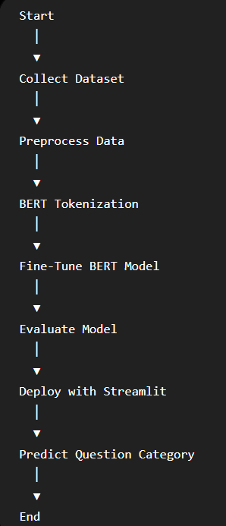
Project Group Members

S.No. | Roll.No. | Student Name
1 | 2420030706 | M.Sai Sahasra
2 | 2420030739 | Ch.Lucky Reddy
3 | 2420030632 | K.Sai Krishna
4 | 2420090006 | R.Vignesh.Reddy

